**CN QUESTIONS**

1. **Short Type Questions** 
   1. What is the topology used in your hostel or lab to connect systems to internet? Explain the benefits of above topology. (2013 END-QS)
   2. In a GO-Back-N-ARQ, if the window size is 63, what is the range of sequence numbers? (2014 END-QS)
   3. Distinguish transmission and propagation delay. (2014 END-QS)
   4. What is a Socket? How a socket is uniquely identified? (2015 END-QS)
   5. Compare and contrast flow control and Error control.(2015 END-QS)
   6. What is the difference between connectionless and connection oriented services? Why connectionless service is used though of connection oriented service is available. (2015 END-QS)
   7. List two ways in which the OSI reference model and the TCP/IP are the same & list two ways in which they differ.(2016 END-QS)
   8. List out the advantages and drawbacks of bus topology.Suppose you wanted to do a transaction from a remote client to a server as fast as possible. Would you use UDP or TCP? Why? (2016 END-QS)
   9. Discuss the significance of MAC address, IP address and port numbers. (2016 END-QS)
   10. In Stop-and-Wait ARQ, the sequence numbers are based on modulo-2 arithmetic. Why? (2016 END-QS)
   11. Four bits are used for sequence numbering in a sliding window protocol used in a computer network. What is the maximum window size? (2015MID-QS)
   12. Which of the following TCP/IP protocols is used for remote terminal connection services? (2015MID-QS)
2. TELNET (b) FTP (c) RARP (d) UDP (e) None of these choices
   1. _____________protocol is used for sending email on the Internet?
   2. Which one of the following uses the greatest number oflayers in the TCP/IP stack? (2015MID-QS)
3. Switch (b) Repeater (c) Router (d) End Host (e) None of these choices
   1. _________is the default port number for HTTP? (2015MID-QS)
   2. A basic telephone network is an example of_____________. (2015MID-QS)
4. Packet Switching (b) Cell Switching (c) Circuit Switching (d) Message Switching

(e) none of these choices

* 1. Which one of the following is used to communicate between different networks? (2015MID-QS)

1. ADSL (b) HDSL (c) Gateway/Router (d)Modem (e) None of these choices
   1. In TCP, if the value of HLEN is 0111, how many bytes of [2 x 10 options are included in the segment? (2015 END-QS-NEW)
   2. In a TCP connection, the initial sequence number at the client site is 210. The client opens the connection, sends 1000 bytes of data successfully, and closes the connection. What is the value of the sequence number in each of the following segments sent by the client? (2015 END-QS-NEW)
2. The SYN segment
3. The FDN segment
   1. Briefly explain how exactly the flow occurs among various layers in OSI model when you are giving any URL address in any browser. (2016 END-QS-NEW)
   2. In TCP, does a FIN segment close a connection in only one direction or in both directions? Explain. (2016 END-QS-NEW)
   3. During data communication in mobile network whether packet switching or circuit switching is prefered, explain. (2016 END-QS-NEW)
   4. Assume propagation delay is less than transmission delay on a link connecting host A to B. If host A starts transmission at t=0, at time equal to transmission delay, where is the first bit of the packet? (2015 MID-QS-NEW)
   5. Suppose a user wants to acess a webpage using a given URL. The IP address of the HTTP server is initially unknown. What transport and application-layer protocols besides HTTP are needed in this scenario? (2015 MID-QS-NEW)
   6. Suppose you want to do a transaction from a remote client to a server as fast as possible. what transport layer protocol will you use and Why? (2015 MID-QS-NEW)
4. **Long Type Questions** 
   1. Explain different layersof OSI model. Compare it with layers in TCP/IP model. (2013 END-QS)
   2. Explain the design of Go-back-to-N flowcontrol protocol with he help of a diagram. How does Go-back-to-N protocol improves efficiency over Stop and Wait protocol? (2013 END-QS)
   3. If m number of bits are used for representing a sequence number in selective repeat ARQ, then the maximum size of sliding window is 2m-1. Justify this statement using aboundary case example. What will happen if the sizeof sliding window exceeds 2m-1? (2013 END-QS)
   4. Write down different layers of TCP/IP model. Explain each One of them with example. (2013 END-SUPL-QS)
   5. What isthe difference between Packet switching and Circuit switching? Explain with examples. (2013 END-SUPL-QS)
   6. What is ICMP protocol? Why it isused? What is the minimum size of an ICMP-v4 packet which in turn carries an ICMP-v4 packet? What is the maximum size? (2013 END-SUPL-QS)
   7. In a TCP Connection, the initial sequence number at the client side is 2171. The client opens the connection, send three segments, the second of which carries 1,000 bytes of data and closes the connection. What is the value of the sequence number in each of the segments sent by the client? (2013 END-SUPL-QS)
5. The SYN Segment
6. The data segment
7. The FIN segment
   1. Compare and contrast GO-Back-N-ARQ protocol with Selective-Repeat ARQ protocol w.r.t. send and receive window size, timers and acknowledgements. (2014 END-QS)
   2. List the four broad class of services that a transport protocol can provide. For each of service classes, indicate if either UDP or TCP (or both) provide such a sevice. (2014 END-QS)
   3. Describe the various layers of OSI Model. Explain the functionality of for each layer. (2015 END-QS)
   4. What is DNS? Briefly explain the Directory Services. (2015 END-QS)
   5. Describe the E-mail architecture in detail. Explain why SMTP can not be used at the receiver end for receiving the E-mail. (2015 END-QS)
   6. What is stop and wait protocol? A Stop and wait protocol has a frame size of 100 bits and transmission speed of 10 Mbps and ACK frame is 100 bits.Distmce and Velocity of Propagation is 1OOkms andm/sec respectively. Calculate bandwidth utilization of the link. (2015 END-QS)
   7. Using 5-bit sequence number, what is the maximum size of the send and receive windows for each of the following protocols? (2016 END-QS)
8. Stop-Wait protocol
9. (ii)) Selective-Repeat ARQ
   1. The distance from earth to a distant planet is approximately 9 x 10^10 m. What is the channel utilization if a stop-and-wait protocol is used for frame transmission on a 64 Mbps point-to-point link? Assume that the frame size is 32 KB and the speed of light is 3 x 10^8 m/s. (2016 END-QS)
   2. Explain, how data communication between sender and receiver happens using different layers of TCP/IP Stack. (2016 END-QS)
   3. Describe how Web caching can reduce the delay in receiving a requested object. Will Web caching reduce the delay for al l objects req uested by a user or for only some of the objects? Why?(2016 END-QS)
   4. What advantage does a circuit-switched network have over a packet-switched network? What advantages does TDM have over FDM in a circuit-switched network? (2015MID-QS)
   5. Using Stop-and-Wait, how many bits are needed for the sequence number? Justify with proper example. (2015MID-QS)
   6. Consider a packet switching architecture. (2015MID-QS)
10. What are the main components of delay when we use packet switching and give details of

each delay?

1. What is the difference between transmission delay and propagation delay?
2. How is propagation delay affected if the length of the packet is increased?
   1. What is the difference between pull and push network protocols? Explain the difference by using two example protocols. (2015MID-QS)
   2. Describe how Web caching can reduce the delay in receiving a requestedobject. Will Web caching reduce the delay for all objects requested by a useror for only some of the objects? Why? (2015MID-QS)
   3. Briefly describe what HTTP is and sketch its operation using a simple figure (i.e., the typical messages exchanged during operation of HTTP). (2015MID-QS)
   4. What is DNS and what is it used for? If all DNS servers could be "crashed" (taken offline), what would happen to the Internet (be precise). (2015MID-QS)
   5. Sketch the TCP connection initiation and connection termination packet flows using a timing diagram. (2015MID-QS)
   6. Consider the use Of 10 K-bit size frames on a 10 Mbps satellite channel with 270 ms delay. What is the link utilization for stop-and-wait ARQ technique assuming P = 10-3. (2015MID-QS)
   7. OSI is called as a model, whereas TCP/IP is called as a protocol suite. Be precise. (2015MID-QS)
   8. List out the advantages and disadvantages of star and ring topology. (2015 END-QS-NEW)
   9. Explain in detail how SMTP send your email to your friend's mailbox. (2015 END-QS-NEW)
   10. The distance from earth to a distant planet is approximately 9 x 1010 m. What is the channel utilization if a stop-and-wait protocol is used for frame transmission on a 64 Mbps point·-to-point link? Assume that the frame size is 32 KB and the speed of light is 3 x108 m/s. (2015 END-QS-NEW)
   11. Differentiate switch and hub. Expl ain, how data communication is carried out using star topology with central node both as a switch or a hub. (2016 END-QS-NEW)
   12. What is ICMP protocol and how it is used in ping utility? (2016 END-QS-NEW)
   13. A channel has a bit rate of 4 Kbps and a propagation delay of 20 msec. For what frame size does the stop-and-wait protocol gives a channel utilization of at least 50%. (2015 MID-QS-NEW)
   14. Explain, why SMTP can not be used at t'.!e receiver end for receiving the E-mail. (2015 MID-QS-NEW)
   15. Explain the relationship among message, segment, datagram, a.n. d a frame. Also name the layers at which they are generated. (2015 MID-QS-NEW)
3. **Short Note Questions** 
   1. UDP (2013 END-QS)
   2. TCP Three-way Handshaking (2015 END-QS)
   3. Packet Switching Vs. Circuit switching (2013 END-QS)
   4. Host-byte-order Vs. Network-byte-order (2014 END-QS)
   5. Web Caching (2015 END-QS)
   6. Electronic mail (2016 END-QS)
   7. Checksum (2015MID-QS)
   8. Utilization of stop and wait ARQ (2015 MID-QS)
   9. Connection oriented vs Connectionless communication (2015 MID-QS)
   10. Connection oriented socket (2016 END-QS-NEW)
   11. ARP vs RARP (2016 END-QS-NEW)
   12. Recursive vs Iterative DNS query (2015MID-QS-NEW)
   13. Client-server vs Peer-to-Peer Architecture (2015 MID-QS-NEW)
   14. Persistent vs Non-Persistent Connections (2015 MID-QS-NEW)
   15. Congestion Control
4. **Network layer**
   1. Which of the following is public IP address ?

(A) 10.15.14.12 (B) 192.168.52.62 (C) 172.32.1.1 (D) None of the Above

**Ans:** C

**Explanation:**

Range of Private IP

10.0.0.0 – 10.255.255.255

172.16.0.0 – 172.31.255.255

192.168.0.0 – 192.168.255.255

* 1. Which of the following IP address can be used in WAN?

(A) 10.0.0.1 (B) 172.16.0.10 (C) 15.1.5.6 (D) None

**Ans:** C

**Explanation:**

10.0.0.1 and 172.16.0.10 are private IP address. Thus cannot be used in WAN. 15.1.5.6 is a ublic IP address.

* 1. Which of the following can be used as both Source and Destination IP ?

1. 198.168.1.255 (B)10.0.0.1 (C) 127.0.0.1 (D) 255.255.255.255

**Ans:** B

**Explanation:**

192.168.1.255 is a Direct Broadcast Address (DBA), DBA can’t be used as Source Address. 127.0.0.1 Loop back address agsin can’t be used as source address. 255.255.255.255 is Limited Broadcast Address, which cannot be used as DBA. 10.0.0.1 can be both used as both source and destination IP address.

* 1. An organization has a class B network and wishes to form subnets for 64 departments. What would be thr subnet mask? (GATE-2005)

**Ans:** 255.255.252.0

**Explanation:**

64 department = 26 => 6 bits required for subnet

Class B network, so first two octet would be all 1 and rest 6 bits one followed by zeros.

Subnet mask = 255.255.11111100.00000000 =>255.255.252.0

* 1. If a class B network on the Internet has a subnet mask of 255.255.248.0, what is the maximum number of hosts per subnet? (GATE-2008)

**Ans:** 2046

**Explanation:**

Class B, first two octet netid, next two octet 248.0 =>11111000.00000000 => 11 zeros

=> Number of hosts = 211-2=2048-2=2046

* 1. In a class B subnet, we know the IP address of one host and the mask as given below:

IP address: 125.134.112.66

Mask: 255.255.224.0

What is the first address(Network address)?

(A) 125.134.96.0 (B) 125.134.112.0 (C) 125.134.112.66 (D) 125.134.0.0

**Ans:** A

**Explanation:**

We can obtain Network Address by performing bitwise and operation of IP address and Subnet Mask.

IP Address = 125.134.112.66 = 125.134.01110000.66

Mask = 255.255.224.0 = 255.255.11100000.0

------------------------------------------------------------------------------------------

IP Address & Mask =125.134.01100000.0=125.134.96.0 <= Network Address

* 1. The address of a class B host is to be split into subnets with a 6-bit subnet number. What is the maximum number of subnets and the maximum number of hosts in each subnet?

(A) 62 subnets and 262142 hosts. (B) 64 subnets and 262142 hosts.

(C) 62 subnets and 1022 hosts. (D) 64 subnets and 1024 hosts.

**Ans:** 62 subnets and 1022 hosts.

**Explanation:**

6 bit subnet number => Total number of subnets = 26-2 = 62

In class B host bits=16-6=10=>Total number of hosts = 210-2 = 1022

Maximum number of subnets = 2^6-2 =62.

Note that 2 is subtracted from 2^6. The RFC 950 specification reserves the subnet values consisting of all zeros (see above) and all ones (broadcast), reducing the number of available subnets by two.

Maximum number of hosts is 2^10-2 = 1022.

2 is subtracted for Number of hosts is also. The address with all bits as 1 is reserved as broadcast address and address with all host id bits as 0 is used as network address of subnet.

In general, the number of addresses usable for addressing specific hosts in each network is always 2^N – 2 where N is the number of bits for host id.

* 1. The subnet mask for a particular network is 255.255.31.0. Which of the following pairs of IP addresses could belong to this network? (GATE-2003)

(A) 172.57.88.62 and 172.56.87.233 (B) 10.35.28.2 and 10.35.29.4

(C) 191.203.31.87 and 191.234.31.88 (D) 128.8.129.43 and 128.8.161.55

**Ans:** D

**Explanation:**

Suppose we have a host A with IP Address IPA and Subnet mask of the subnet of which A is a part is Ms. Now when A wants to send packet to a host B with an IP address say IPB, then A will first AND the subnet-Mask Ms with IPA to find out the subnet-id IDN of the subnet in order to identify whether IPB belongs to the same network. Now if B also belongs to the same network, then IPB BITWISE-AND Ms must be equal to IDN which A has calculated. If IPA and IPB belongs to same network, we must have

**IPA BITWISE-AND Ms == IPBBITWISE-AND Ms**

Out of the 4 options, only option D matches.

128.8.129.43 & 255.255.31.0 = 128.8.1.0

128.8.161.55 & 255.255.31.0 = 128.8.1.0

* 1. Suppose computers A and B have IP addresses 10.105.1.113 and 10.105.1.91 respectively and they both use the same net mask N. Which of the values of N given below should not be used if A and B should belong to the same network? (GATE-2010)

(A) 255.255.255.0 (B) 255.255.255.128 (C) 255.255.255.192 (D) 255.255.255.224

**Ans:** D

**Explanation:**

The last octets of IP addresses of A and B are 113 (01110001) and 91 (01011011). The netmask in option (D) has first three bits set in last octet. If netmask has first 3 bits set, then these bits nmust be same in A and B, but that is not the case. In simple words, we can say option (D) is not a valid netmask because doing binary ‘&’ of it with addresses of A and B doesn’t give the same network address. It must be same address as A and B are on same network. See this for more details.

* 1. The broadcast address for IP network 172.16.0.0 with subnet mask 255.255.0.0 is

(A) 172.16.0.255 (B) 172.16.255.255 (C) 255.255.255.255 (D) 172.255.255.255

**Ans:** B

**Explanation:**

IP Address = 172.16.0.0

Mask = 255.255.0.0

------------------------------------------------------------------------------------------

IP Address & Mask =172.16.0.0 <= Network Address => 172.16.255.255 is the DBC (Direct Broacast Address)

* 1. If Direct Broadcast Address of subnet is 201.15.16.31. Which of the following will be subnet mask ?

1. 255.255.255.240 (B) 255.255.255.192 (C) 255.255.255.198 (D) None Of the Above

**Ans:** A

**Explanation:**

* 1. If subnet mask 255.255.255.224, which of the following will be Direct Broadcast address ?

(A) 202.15.19.127 (B) 202.15.19.63 (C) Both a and b (D) None of the Above

**Ans:** C

**Explanation:**

Subnet mask is 255.255.255.11100000

In DBA all host bits are 1.

from option 202.15.19.011 11111 , this can be a DBA.

202.15.19.001 11111 ,this can also be a DBA.

* 1. A packet addressed to 128.48.64.0 came to a router having routing table as follows.

[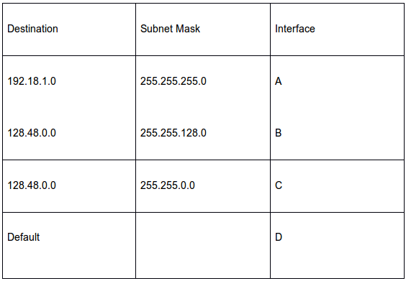](https://www.geeksforgeeks.org/wp-content/uploads/gq/2017/01/Mock_3.png)

Which interface will it be forwarded to ?

(A) A (B) B (C) C (D) D

**Ans:** B

**Explanation:**

Logical AND operation between subnet mask and IP address gives the subnet ID.

a)128.48.64.0 & 255.255.255.0 = 128.48.64.0 which is not equal to the destination so the packet will not be forwarded to the interface A.

b) 128.48.64.0 & 255.255.128.0 = 128.48.0.0 so packet can be forwarded to B.

c) 128.48.64.0 & 255.255.0.0 = 128.48.0.0 so packet can be forwarded to C.

If two IP addresses match then the packet should be forwarded to the subnet with more number of 1’s in the subnet mask.

Hence, router will forward the packet to interface B.

* 1. (GATE-2004)

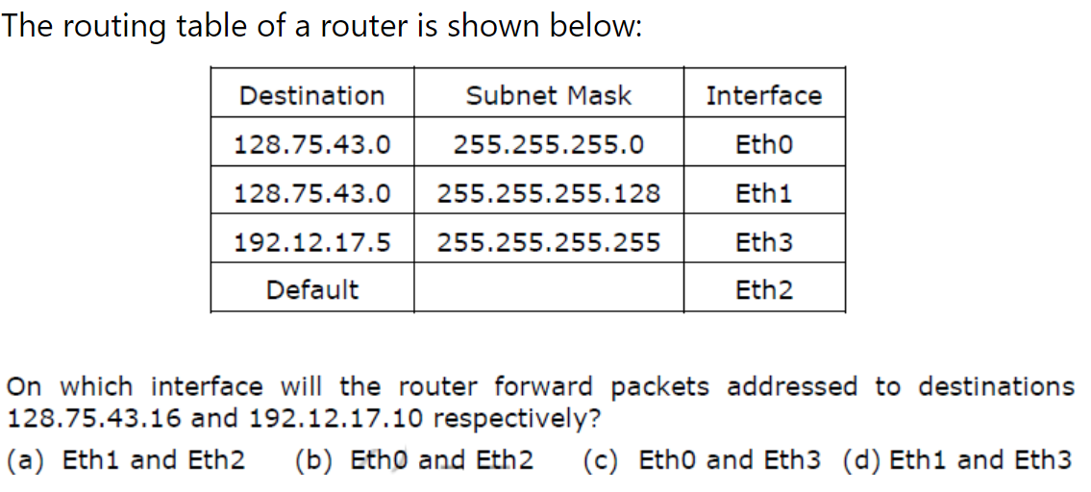

**Ans:** A

**Explanation:**

IP Address = 128.75.43.16

Subnet Mask = 255.255.255.0

------------------------------------------------------------------------------------------

IP Address & Mask =128.75.43.0 <= Network Address => packet is forwarded to eth0

IP Address = 128.75.43.16 = 128.75.43.00010000

Subnet Mask = 255.255.255.128 = 255.255.255.10000000

------------------------------------------------------------------------------------------

IP Address & Mask =128.75.43.0 <= Network Address not matched => so packet is is not forwarded to eth3

IP Address = 128.75.43.16

Subnet Mask = 255.255.255.255

------------------------------------------------------------------------------------------

IP Address & Mask =128.75.43.16 <= Network Address => packet is forwarded to eth1

* 1. Consider the following routing table at an IP router:

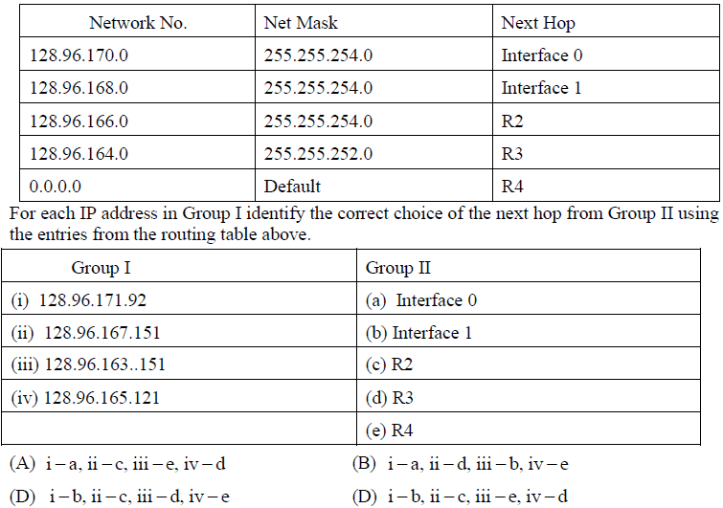

**Ans:** A

**Explanation:**

The next hop is decide according to the longest prefix matching.

128.96.171.92

* 1. Host X has IP address 192.168.1.97 and is connected through two routers R1 and R2 to an­other host Y with IP address 192.168.1.80. Router R1 has IP addresses 192.168.1.135 and 192.168.1.110. R2 has IP addresses 192.168.1.67 and 192.168.1.155. The netmask used in the network is 255.255.255.224. Given the information above, how many distinct subnets are guaranteed to already exist in the network?

(A) 1 (B) 2 (C) 3 (D) 6

**Ans:** C

**Explanation:**

Given IP addresses are of Class C

default Mask for class C = 24

Here given mask is 11 bits ( 11111111 11111111 11111111 11100000)

subnet ID: 3 bits

existing subnets: 011, 010 and 100

**Alternative approach –**

Each link which connects a router-router, or a router-host(s) has a different subnet. In this case, there are 3 subnets,

One connecting Host X to Router R_1

One connecting Router R_1 to Router R_2

One connecting Router R_2 to Host Y

We can also find the number of subnets by couting the number of network prefixes as each network ID corresponds to a subnet. Subnet Mask – 255.255.255.224 or /27.

In the following table, Network ID only displays bits 24 to 26 since bits 0 to 23 are the same for all subnets. Subnet ID is obtained after AND’ing the IP address with the subnet Mask.

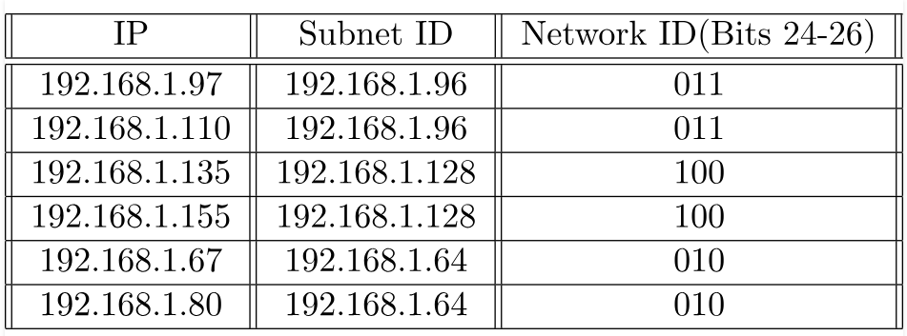

* 1. A classless address is given as 167.199.170.82/27. Findout the following.

1. Number of IP addresses in the block
2. Find out the range of IP addresses in the block. (First IP address and last IP address in the block.
   1. The range of IP addresses in a block are given. Test whether they satisfy the CIDR block or not. If satisfied represent it in CIDR notation.
3. 100.20.30.32 to 100.20.30.47
4. 30.20.18.32 to 30.20.18.67
5. 200.20.30.64 to 200.20.30.127
   1. An ISP has requested a block of 1000 addresses. Then find a valid block in CIDR notation that is granted to the ISP. A block 18.14.12.0/22 is available. Can it be granted to ISP? Justify your answer.
   2. Host X has IP address 192.168.1.97 and is connected through two routers R1 and R2 to an­other host Y with IP address 192.168.1.80. Router R1 has IP addresses 192.168.1.135 and 192.168.1.110. R2 has IP addresses 192.168.1.67 and 192.168.1.155. The netmask used in the network is 255.255.255.224. Which IP address should X configure its gateway as?

(A) 192.168.1.67

(B) 192.168.1.110

(C) 192.168.1.135

(D) 192.168.1.155

**Ans:** B

**Explanation:**

For: 192.168.1.110/28

For network address keep Network bits as it is and put host bits =0 in any given IP address.

Network address = 192.168.1.01100000 =>192.168.1.96

For: 192.168.1.97/28

Network address = 192.168.1.01100000 =>192.168.1.96

* 1. Two computers C1 and C2 are configured as follows. C1 has IP address 203.197.2.53 and netmask 255.255.128.0. C2 has IP address 203.197.75.201 and netmask 255.255.192.0. which one of the following statements is true? (GATE-2006)

(A) C1 and C2 both assume they are on the same network

(B) C2 assumes C1 is on same network, but C1 assumes C2 is on a different network

(C) C1 assumes C2 is on same network, but C2 assumes C1 is on a different network

(D) C1 and C2 both assume they are on different networks

**Ans:** C

**Explanation:**

* 1. An Internet Service Provider (ISP) has the following chunk of CIDR-based IP addresses available with it: 245.248.128.0/20. The ISP wants to give half of this chunk of addresses to Organization A, and a quarter to Organization B, while retaining the remaining with itself. Which of the following is a valid allocation of address to A and B? (GATE-2012)

(A) 245.248.136.0/21 and 245.248.128.0/22

(B) 245.248.128.0/21 and 245.248.128.0/22

(C) 245.248.132.0/22 and 245.248.132.0/21

(D) 245.248.136.0/24 and 245.248.132.0/21

**Ans:** A

**Explanation:**

* 1. An IP router implementing Classless Inter-domain routing (CIDR) receives a packet with address 131.23.151.76. The router’s routing table has the following entries: (GATE-2014)

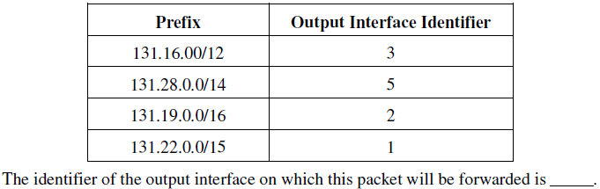

**Ans:** 1

**Explanation:**

* 1. In the network 200.20.11.144/27, the fourth octet (in decimal) of the last IP address of the network which can be assigned to a host is ________. (GATE-2015)

**Ans:** 158

**Explanation:**

* 1. In class B if subnet mask is 255.192.0.0 Total Number of networks than can be joined

(A) 32

(B) 64

(C) 16

(D) None of the Above

**Ans:** B

**Explanation:**

Number of network can be joined is 2^n , n is the number bits borrowed from network bits.

Default Subnet mask 255.255.0.0 .i.e 11111111.11111111.00000000.0000000

Given Subnet mask is 11111111.11000000.00000000.0000000

Number of bits taken from network bits = 6

Number of subnets = 2^6 =64

* 1. F
  2. F
  3. F
  4. F
  5. f

1. G
2. **DATA LINK LAYER**

**Short Type Questions**

* 1. What is the topology used in your hostel or lab to connect systems to internet? Explain the benefits of above topology. (2013 END-QS)

**Long Questions**

* 1. What is the topology used in your hostel or lab to connect systems to internet? Explain the benefits of above topology. (2013 END-QS)

**Short Note Questions**

* 1. What is the topology used in your hostel or lab to connect systems to internet? Explain the benefits of above topology. (2013 END-QS)